 |  | 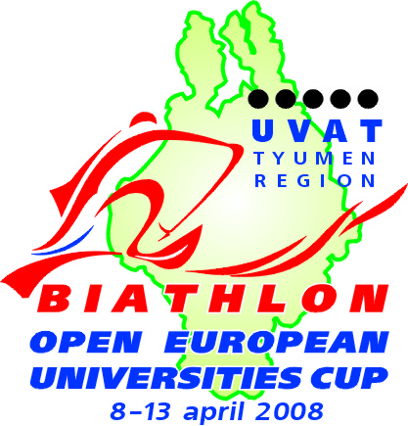 | 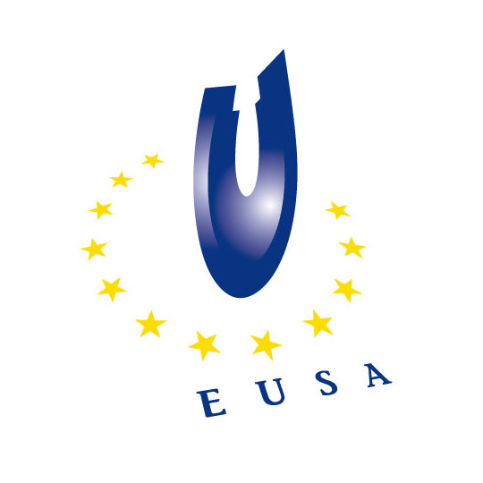

1st EUROPEAN UNIVERSITIES BIATHLON CUP
APRIL 8 - 13, 2008 / Uvat, Russia

INVITATION
On behalf of the European University Sports Association (EUSA), the Russian Student Sport Union (RSSU) and the Organising Committee, we have the honour to invite your National University Sports Federation
to participate in the
1st European Universities Biathlon Cup
to be held in Uvat, Russia from April 8 to April 13, 2008


We may remind you that the deadline for applications has been determined as
March 8, 2008

All relevant information is published on the EUSA website: www.eusa.eu
and on the official website of the event:
www.studsport.ru

We would be honoured to welcome teams from your country!

With best sports regards,

 | 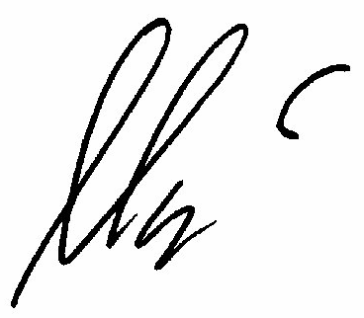 | 
Alberto Gualtieri  President of EUSA | Oleg Matysin  President of RSSU | Dmitr V. Gramotin  President of OC

